Project Proposal
Team 6
Tristan McRae and Devon Monaco

Scope

The robot designed for this project will be capable of autonomously roaming within a designated area, recognizing intruders that enter the area, driving to the intruder, firing small discs from an attached disc shooter at the intruder, and continuing to follow the intruder until it leaves the designated area. The area will be an approximately 3’x3’ white sheet with black tape around the edges. The robot will also use its IR sensor to recognize the discs it fires as belonging there and not being an intruder. The robot will not launch the discs on its own, it will simply trigger an external, attached, disc launcher to fire. The possibility of adding a disk shooter angle adjustment will be explored to improve firing range accuracy. The robot will not actively look for intruders, it will just react if it happens to see one.

Estimated Specs

Specification | Estimated Value | Units
Mass | 2 | kg
Volume Envelope | 20x15x15 | cm
Power Consumption | 30 | W
Drive Speed | 0.5 | m/s
Disc Accuracy | 20 | %
Intruder Recognition | 95 | %

Logic Flowchart

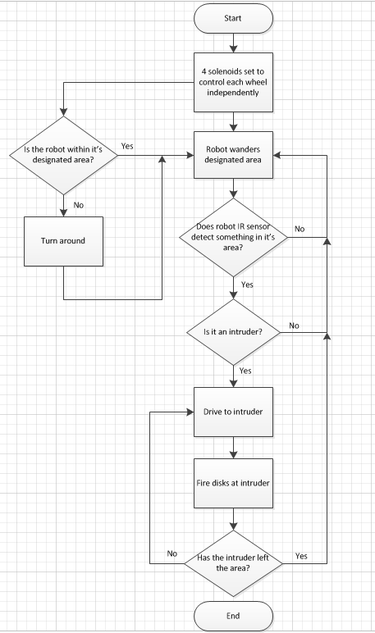

Bill of Materials

Item | Quantity | Source | Unit Price ($) | Total Price ($)
Wheels | 4 | Lab | 0 | 0
Continuous Servos | 4 | BotBrain | 11 | 44
IR Sensor | 1 | Sharp | 10 | 10
LiPo Battery | 1 | Already Owned | 0 | 0
Arduino Uno | 1 | Already Owned | 0 | 0
Wire Set | 1 | Already Owned | 0 | 0
Disc Shooter | 1 | ToySmith | 8 | 8
Chassis | 1 | Scrap Material | 0 | 0
Solenoid | 1 | uxcell | 12 | 12
White Sheet | 1 | Already Owned | 0 | 0
Roll of Black Tape | 1 | Already Owned | 0 | 0
Total | N/a | N/a | N/a | 74

Team Roles

Tristan McRae – Lead Software Engineer
Devon Monaco – Lead Hardware Engineer

Many aspects of the project will be handled by both team members but due to past experience and interests, Tristan will take more of a focus on the software and Devon will focus more on the hardware.

Team Norms and Values

Behaviour Expectations
- Members will do their best to complete action items before due dates set by the team
- Team members will treat each other with respect and allow each other to present ideas openly.
- Abides by the Engineering Code of Ethics

Resolving Conflicts:
- Open communication is encouraged between all group members and potential issues should be brought up as soon as they are recognized.

Assigning Work:
- Group members should volunteer for work regularly.
- Group members should be willing to help another complete tasks and be willing to ask for help when necessary.
- Team members are expected to finish their tasks on time and with a good level of quality.
  - If there is a potential for missing a deadline, the rest of the team should be notified as quickly as possible.
  - Feedback is encouraged with our group and to be expected of all submissions by all members. Timeliness is key though on drop-dead issues.
- Team members should actively review each others work on key deliverables and provide constructive feedback.

Group meetings:
- All group meetings will be scheduled two plus days in advance.
- Both group members are expected to attend all meetings.
  - Exceptions will be made for any conflicts as long as the other member is notified.
- Meetings should be effective and decisive.
- Punctuality for group meetings is casual, but members should notify the team if they will be late.
- All group members should arrive at least 5 minutes early to meetings with the professor or TA.

